

**Smile Suite**

**:**

**Cloud Based Dental Clinic as a Service**

Capstone Project Presented to

The Faculty of the College of Engineering & Information Technology

Surigao

del Norte State University

Surigao City

In Partial Fulfillment

Of the

Requirements for the Degree

Bachelor of Science in Information

Technology

By

**Dy Mark B. Gales**

**Marc V. Salamanca**

May 2025

**SMILE SUITE: CLOUD BASED DENTAL CLINIC AS A SERVICE**

# ABSTRACT

*Dental clinics in the Philippines, particularly those outside major urban centers, continue to face significant operational inefficiencies due to their reliance on manual processes for scheduling, record-keeping, inventory monitoring, and patient communication. Enhaynes Dental Clinic, located in Surigao, exemplifies this challenge, encountering frequent appointment overlaps, lost records, stock depletion, and disorganized payment documentation. This capstone project proposes the development of Smile Suite: A Cloud-Based Dental Clinic-as-a-Service Management System, designed to modernize these workflows through digital automation. Smile Suite is a multi-tenant, webbased platform featuring a Laravel/PHP backend and a MySQL database, coupled with a responsive React.js frontend. The system enables real-time online appointment scheduling, centralized patient records, treatment history tracking, inventory management with lowstock alerts, and automated SMS and email reminders through the Twilio API. A dedicated administrative dashboard provides clinic staff with tools for managing schedules, monitoring finances, and generating business intelligence reports that support strategic decision-making. In contrast to traditional linear models, the project adopts the Rapid Application Development (RAD) methodology to ensure continuous stakeholder feedback and iterative improvements throughout the development cycle. Usability and performance will be evaluated based on reductions in administrative workload, appointment no-shows, and inventory-related disruptions. Beyond Enhaynes Dental Clinic, the system is designed for scalability, offering other clinics nationwide a cost-effective, cloud-based solution aligned with the Department of Health’s eHealth Strategic Framework (2023–2028) [48]. The expected outcome is a functional, user-centered clinic management system that enhances efficiency, reduces human error, and empowers dental practitioners with datadriven tools, ultimately serving as a model for digital transformation in small to mid-sized dental clinics across the Philippines.*

**KEYWORDS**

*cloud-based system, dental clinic system, laravel php, patient portal, philippines, react.js*

# INTRODUCTION

The digital transformation of dental clinics in the Philippines, especially small to mid-sized practices, remains critically underdeveloped despite the growing availability of affordable cloud technologies. Clinics in provincial cities like Surigao still rely on manual systems for essential tasks such as appointment scheduling, inventory tracking, and patient record management which leads to administrative overload and reduced service quality. A nationwide survey by the Department of Science and Technology (DOST) and the Philippine Council for Health Research and Development revealed that over 70% of small healthcare providers in the Philippines lack digital infrastructure, mainly due to cost concerns and limited technical capacity [41]. These outdated workflows result in increased human error, frequent appointment overlaps, and inefficient inventory usage.

This capstone project introduces Smile Suite: A Cloud-Based Dental Clinic-as-aService Management System, a comprehensive, multi-tenant platform designed to automate key clinic operations while enabling scalability for multi-branch use. The system addresses three core limitations observed at Enhaynes Dental Clinic and similar practices: (1) lack of real-time scheduling and inventory control, (2) inability to generate actionable business reports for clinic decision-making, and (3) poor communication channels between clinic and patients. A study emphasized that small clinics adopting digital platforms for appointment booking and treatment logging reported a 25–35% improvement in workflow efficiency and a 20% increase in patient satisfaction due to faster service [42].

Smile Suite incorporates both SMS notification features (using Twilio API) and email reminders to reduce the current 15–20% no-show rate observed at Enhaynes Dental Clinic. According to a report, SMS open rates in the Philippines are as high as 97%, making it one of the most effective channels for appointment reminders [43]. The system is also built as a multi-tenant, cloud-based architecture, which means new dental clinics can register and use the system independently while benefiting from shared infrastructure which is an approach aligned with the scalable healthcare delivery models advocated by the Asian Development Bank’s Digital Health Strategy [44].

Moreover, Smile Suite is designed with a strong emphasis on decision support tools. It includes real-time dashboards, reports on patient trends, inventory turnover, and revenue tracking, enabling clinic administrators to make data-driven decisions. This feature directly addresses what the World Health Organization identifies as one of the most common weaknesses in health facility management: the absence of operational analytics and monitoring tools in low-resource settings [45].

This study is guided by three core research questions formulated through preliminary stakeholder interviews and analysis of industry trends: (1) To what extent can automated scheduling and inventory management reduce operational inefficiencies in small dental clinics? (2) What technical and usability factors most influence the successful adoption of a multi-clinic dental management platform? (3) And how effectively can standardized reporting tools support financial and clinical decision-making for clinic administrators? These questions shape the direction of system development and evaluation, ensuring the proposed solution aligns with real-world operational needs and management priorities.

In line with the dynamic and iterative nature of system development in healthcare settings, this project will adopt the Rapid Application Development (RAD) methodology. RAD supports continuous feedback and iterative prototyping which are critical features when designing for end-users like dentists and administrative staff who may have limited technical backgrounds [46]. The broader significance of Smile Suite lies in its potential to serve as a scalable, replicable model for digitizing dental clinic operations nationwide. This aligns with the Philippine Department of Health’s eHealth Strategic Framework and Plan, which prioritizes ICT-based systems to improve healthcare delivery and accessibility [47]. By enhancing operational efficiency, reducing appointment no-shows, and enabling datadriven decision-making through automated reporting tools, this project aims not only to transform Enhaynes Dental Clinic but also to provide a working blueprint for modernizing similar clinics across the country.

## Project Context

Dental clinics in the Philippines, particularly those operating outside major urban centers, continue to face significant operational challenges stemming from their reliance on manual, paper-based systems. Clinics such as Enhaynes Dental Clinic in Surigao experience frequent inefficiencies in appointment scheduling, inventory tracking, and record-keeping issues that directly impact both service delivery and business performance. In these settings, administrative staff often juggle overlapping appointments, mismanaged stock, and delayed communication with patients, leading to increased operational strain and patient dissatisfaction.

Smile Suite: A Cloud-Based Dental Clinic-as-a-Service Management System was conceptualized in response to these persistent challenges. The idea originated from stakeholder interviews and field observations conducted at Enhaynes Dental Clinic, where staff and management expressed a strong need for automation, better data visibility, and a more reliable method for notifying patients about their appointments. Recognizing that many clinics in similar situations share these needs, the system was intentionally designed to support a multi-clinic environment through a cloud-based, multi-tenant architecture. This allows other dental clinics to onboard and utilize the same system without needing to build infrastructure from scratch, addressing both cost and scalability concerns.

Additionally, the project's emphasis on generating business intelligence through real-time dashboards, patient analytics, and financial reports responds to a notable gap in current dental practice management systems: the lack of tools that assist decision-makers in evaluating performance and planning improvements. By integrating SMS notification systems and prioritizing user-friendly reporting tools, Smile Suite aims to bridge the digital divide that prevents small clinics from reaping the full benefits of healthcare IT solutions.

This project not only targets the specific pain points observed at Enhaynes Dental Clinic but also offers a replicable model aligned with national digital health goals. In doing so, it supports broader government initiatives, such as the Department of Health’s eHealth

Strategic Framework (2023–2028) [48], which advocates for scalable, cloud-based solutions to improve access, efficiency, and continuity of care across the Philippine healthcare system.

## Purpose and Description

The primary purpose of this capstone project is to design and develop Smile Suite: A Cloud-Based Dental Clinic-as-a-Service Management System, aimed at modernizing the operational workflows of Enhaynes Dental Clinic while offering a scalable platform for similar clinics across the country. The system is designed to improve the efficiency of daily tasks such as appointment scheduling, patient record management, inventory monitoring, and reporting through an integrated digital platform. By replacing manual, paper-based processes with an automated solution, the system seeks to minimize administrative workload, reduce human error, and support timely and data-driven decision-making.

Smile Suite consists of two major interfaces: one tailored for patients, accessible via web browsers on mobile and desktop devices, and another for clinic staff and administrators, optimized for desktop use. This separation ensures a user-friendly experience for all stakeholders while maintaining system security and data integrity.

For patients, the system allows 24/7 online appointment booking based on real-time availability managed by clinic staff. It dynamically reflects open slots according to the dentist's configured schedule. Once an appointment request is submitted, clinic personnel can review and approve it through the admin panel. Patients can also register accounts to view their treatment history, manage upcoming visits, and receive automated reminders via SMS (Twilio API) and email, significantly reducing no-show rates and enhancing engagement.

For clinic staff, the administrative dashboard centralizes critical functions into a unified and intuitive interface. Staff can manage appointment calendars, update dentist availability, and access comprehensive patient records. Dentists and assistants can log treatments, monitor case progress, and ensure accurate documentation. The system also features inventory tracking with low-stock alerts, payment recording, and financial summaries. Furthermore, built-in reporting tools generate real-time insights on clinic operations including appointment volume, patient trends, treatment breakdowns, and revenue analysis to support better strategic decisions.

Smile Suite’s multi-tenant cloud architecture allows multiple clinics to register and use the platform independently while sharing a robust backend infrastructure. This ensures scalability without compromising customization or performance, making the system suitable for solo practices, group clinics, and dental chains.

By integrating cloud technologies, patient-centric features, and analytics-driven tools, this system aims to elevate both the administrative and clinical functions of dental practices. Ultimately, Smile Suite will serve as a replicable model aligned with the national digital health roadmap, starting with Enhaynes Dental Clinic as the initial deployment site.

## General Objectives of the Study

To develop Smile Suite: A Cloud-Based Dental Clinic-as-a-Service Management System that streamlines core clinical and administrative operations, supports data-driven decision-making, and enables scalability for multi-clinic use. **Specific Objectives**

1. To gather and analyze system requirements from Enhaynes Dental Clinic and similar stakeholders to ensure the solution addresses real-world operational challenges.
2. To design and develop a cloud-based, multi-tenant management information system using the Rapid Application Development (RAD) methodology, incorporating core features such as online appointment scheduling, patient records management, inventory tracking, financial processes and SMS/email notifications.
3. To test and evaluate the system’s usability, functionality, and performance based on stakeholder feedback and real clinic workflows, with a focus on improving efficiency, accuracy, and decision support capabilities.

## Scope and Limitations

This capstone project focuses on the development and implementation of Smile Suite: A Cloud-Based Dental Clinic-as-a-Service Management System, tailored to support the digital transformation goals of Enhaynes Dental Clinic while providing scalable features for future multi-clinic adoption. The system encompasses both patient-facing services and administrative tools, organized across four key operational domains: patient management, clinical workflow, inventory control, and financial reporting.

**Scope of the System:**

1. The system can allow patients to book, cancel, or reschedule appointments online with real-time dentist availability.
2. The system can send automated SMS/email reminders (via Twilio) to reduce no-show rates.
3. The system can enable patients to view their complete treatment history and download reports.
4. The system can allow dentists to update medical records, including diagnoses, procedures, and follow-up plans.
5. The system can generate operational reports (appointments, revenue, inventory status) for administrators.
6. The system can manage multi-clinic workflows, allowing new clinics to register independently.
7. The system can issue low-stock alerts for dental supplies and track item consumption per service.
8. The system can process in-clinic cash payments and update billing records automatically.
9. The system can generate daily financial summaries for clinic owners.
10. The system can connect with SMS/email servers for patient notifications.

**Limitations of the System:**

1. The system cannot support native mobile applications (iOS/Android) due to development resource constraints, and will only be accessible through modern web browsers (Chrome, Firefox, Edge, Safari).
2. The system cannot automate inventory tracking through barcode scanning or RFID technology, nor can it integrate with supplier APIs for real-time stock updates, requiring manual entry by clinic staff.
3. The system cannot integrate with popular Philippine online payment gateways (GCash, PayMaya, credit/debit cards) in its initial deployment, limiting transactions to in-person cash payments with future digital payment support planned.
4. The system cannot handle staff shift scheduling, timekeeping, or payroll calculations, as these features are outside the current project scope focused on core clinical operations.
5. The system cannot directly exchange data with third-party Electronic Health Record (EHR) systems due to compatibility and regulatory challenges, though it maintains modular architecture for potential future integrations.
6. The system cannot operate without an active internet connection, as all data processing occurs on cloud servers, making it unavailable during network outages.

# RELATED LITERATURE Foreign Literature

Digital clinic management systems have been extensively researched, with findings directly applicable to the Smile Suite’s MIS. Web-based dental systems have been shown to reduce administrative tasks by 30–40%, validating the project's automated scheduling feature [1]. Expectation management has been identified as a key patient satisfaction driver, informing the Smile Suite’s email reminders and treatment portal [2]. Additionally, patients prioritize intuitive booking interfaces, guiding the React.js frontend design [3].

Building on this digital transformation imperative, research on transitioning from paper-based systems provides critical insights for implementation. A study found that 68% of clinics using paper records reported disorganization, justifying the Smile Suite’s Laravel-based digital records [4]. Similar success with pediatric health records demonstrated how digital systems can overcome manual record-keeping challenges [5]. However, training needs during EDR adoption were also highlighted, revealing that while 87% of dental professionals recognize electronic systems' potential, 62% express concerns about workflow disruptions—findings that directly influenced the project's phased implementation strategy [6]. The transition to digital systems extends beyond records management, as work on inventory systems demonstrated 37% efficiency gains through RFID tracking and 89% user acceptance rates respectively [7][8], though the Smile Suite adapts these concepts for its Rapid Application Development methodology.

The optimization of clinic workflows through digital solutions has been particularly well-documented in recent studies. Monte Carlo simulations were used to cut inventory costs by 22%, while digital documentation was linked to 37% waste reduction, both providing quantitative evidence supporting the Smile Suite’s operational approach [9][10]. For resource-constrained settings specifically, the importance of simplified tools was emphasized, with 72% of Nairobi clinics underutilizing complex software—a finding that shaped the Smile Suite inventory module's user-friendly design [11]. Further validation comes from studies that demonstrated EHR benefits such as 72% efficiency gains and achieved excellent usability scores (84.3 SUS), reinforcing the project's technical methodology and interface design choices [12][13].

Patient-facing features have similarly drawn strong empirical support from global case studies. One dental appointment system achieved a 72.5 SUS score, while another clinic system reported 100% functionality—both studies informing key aspects of the Smile Suite patient portal [14][15]. The technical foundation of such systems finds support in validations of Laravel’s efficacy for dental records and automated reminders that reduce staff workload by 37% [16][17]. Perhaps most significantly, there is strong patient demand for treatment history access (87%) and demonstrated impact of digital systems on reducing no-shows by 53%—outcomes that are central to the Smile Suite’s value proposition [18][19]. One study caps this body of research with compelling evidence that patient portals can save 51% of scheduling time, providing a comprehensive evidence base for the system's anticipated benefits [20].

# Local Literature

Digital clinic management systems in Philippine settings have produced compelling evidence supporting the Smile Suite MIS approach. Web-based dental systems have achieved "Excellent" FURPS ratings (Functionality=4.74–5.00), validating the project's PHP/MySQL architecture [21]. Appointment wait times were reduced by 40% through Six Sigma methodology, directly informing Smile Suite’s scheduling algorithms [22]. The feasibility of digital dental records was confirmed in National University’s clinical environment, mirroring the Smile Suite’s paperless transition goals [23].

Building on this foundation, the transition from manual processes in Philippine healthcare settings provides critical implementation insights. Centralized electronic records have been shown to reduce data loss by 42% in rural health units, justifying the project's MySQL database design [24]. However, 78% of local HIS face staff resistance, which is a challenge Smile Suite addresses through role-based training modules [25]. Additionally, offline functionality needs due to unstable internet have directly shaped

Smile Suite’s capable architecture [26]. A nationwide review showed only 12% dental clinic digitization, underscoring the urgent need for cost-effective solutions like Smile Suite’s Laravel/React.js stack [27].

The operational optimization documented in Philippine clinical studies further strengthens Smile Suite’s design rationale. One comparable dental system achieved 40% efficiency gains, though Smile Suite extends this with integrated inventory tracking [28]. Centralized supply monitoring was proven to reduce stock expiry by 62%—a finding directly applied to Smile Suite’s real-time alert system [29]. For financial management, digital payments have been shown to cut uncollected balances by 28%, while SMS notifications improved record accuracy by 42% [30][31].

Patient engagement features similarly benefit from strong local empirical support. Appointment efficiency was boosted by 40% using progressive web apps, informing Smile Suite’s React.js interface design [32]. Record processing time was reduced by 49% in a dental clinic setting, though Smile Suite surpasses this with comprehensive treatment history modules [33]. Appointment flexibility was identified as driving 78% patient satisfaction—a key insight shaping Smile Suite’s mobile-responsive portal [34]. These results align with usability scores (>1.79) for dental management systems, confirming that usability directly correlates with adoption rates in Philippine healthcare contexts [35].

Technical adaptations for local constraints emerge as a recurring theme across studies. Efficiency gains of 42% were reported when systems accommodated staff training needs, directly influencing Smile Suite’s intuitive dashboard design [36]. A 68.75% process improvement was achieved despite cost barriers—a gap Smile Suite addresses through open-source technologies [37]. Paperless systems were linked to 40% higher satisfaction, while digital records were proven to reduce errors by 35% [38][39]. One study caps these findings with evidence that trained users improve data accuracy by 38%, completing the evidentiary basis for Smile Suite’s user-centered development strategy [40].

# TECHNICAL BACKGROUND

The Smile Suite: Cloud-Based Dental Clinic-as-a-Service Management System will be developed using a modern, scalable technology stack tailored to the needs of small to mid-sized dental clinics in the Philippines. The backend will be powered by Laravel 11 (running on PHP 8.3), offering a secure, modular, and maintainable structure to support multi-tenant clinic operations. Data will be managed using a MySQL relational database, ensuring efficient and reliable storage of patient records, appointments, inventory logs, and financial transactions.

The frontend of the system will be developed using React.js, delivering a responsive and user-friendly web experience optimized for both desktop and mobile browsers. Communication between the frontend and backend will be handled through RESTful APIs, with Axios used for asynchronous requests and real-time updates where needed. For the current implementation phase, cash-based payment logging will be supported, with integration for e-wallet platforms like GCash considered in future upgrades. Appointment and treatment notifications will be sent via Twilio’s SMS API and email services to reduce patient no-show rates.

To ensure proper version control and team collaboration, Git and GitHub will be used throughout the development lifecycle. Development and local testing will be performed on WampServer, simulating the production environment before cloud deployment. Upon completion, the system will be deployed on a cloud-based hosting platform, supporting high availability, data backup, and multi-clinic access via the internet.

This technology stack was selected based on its cost-effectiveness, scalability, and accessibility, making it ideal for clinics like Enhaynes Dental Clinic while also supporting long-term expansion to other practices nationwide.

# Hardware Specification

*Table 1. Hardware Specifications*

|  |  |  |
| --- | --- | --- |
| **Component** | **Requirements** | **Cost** |
| Mobile Device  (Patient) | Android 8.0+ or iOS 12+. ≥ 4 GB  RAM | ₱5,000 |
| Processor | Intel Core i5-11400 (11th Gen) 6-  Core 2.6GHz | ₱12,500 |
| Motherboard | MSI B560M PRO-VDH WIFI  (mATX) | ₱5,800 |
| RAM | 16GB DDR4 3200MHz (2x8GB  Dual Channel) | ₱3,200 |
| Storage | 512GB NVMe SSD (WD Blue SN570) + 1TB HDD (Backup) | ₱3,500 |
| Casing | Tecware Nexus Air (mATX) with  4 fans | ₱2,300 |
| PSU | FSP HV Pro 550W 80+ White | ₱2,100 |
| Monitor | 21.5" IPS 1080p (Acer SA220Q) | ₱5,800 |
| Keyboard & Mouse | Logitech MK270 Wireless Combo | ₱1,200 |
| Printer | Epson L3210 EcoTank (Color  All-in-One) | ₱9,999 |
| Router | TP-Link Archer AX10 (Wi-Fi 6) | ₱3,500 |
| Network | PLDT Fiber All Plan 200 mbps | ₱1,799 |
| **Total Hardware** |  | ₱**56,698** |

The hardware specification centers around a robust clinic workstation built with an Intel Core i5-11400 processor (11th Gen) and 16GB DDR4 RAM, ensuring smooth operation of the Smile Suite management system even during peak hours. The 512GB NVMe SSD provides fast boot times and application loading for daily clinic operations, while the additional 1TB HDD offers ample backup storage for patient records and system data. Critical supporting components like the MSI B560M motherboard, reliable 550W PSU, and well-ventilated Tecware casing create a stable foundation for 24/7 clinic operations, with the total core system cost remaining budget-friendly at ₱25,900 (processor to casing).

The specification includes essential peripherals tailored for dental clinic workflows, including a 21.5" IPS monitor for clear patient record viewing and a wireless Logitech keyboard/mouse set for hygienic, clutter-free operation. The Epson L3210 EcoTank printer was specifically selected for its cost-effective ink system, handling everything from patient receipts to insurance forms. Networking components like the Wi-Fi 6 router ensure stable connectivity for multiple devices, while the PLDT Fiber 200Mbps plan guarantees uninterrupted access to the cloud-based system, crucial for real-time data synchronization across services.

For patient-facing needs, the specification accounts for affordable Android/iOS devices (≥4GB RAM) that can access the appointment portal, maintaining accessibility.

The total hardware investment of ₱58,698 represents a comprehensive yet cost-optimized setup, with each component selected for reliability in a clinical environment. This configuration not only supports current operational needs but allows for future expansion, such as adding more workstations or upgrading storage capacity as the clinic grows, ensuring long-term viability of the Smile Suite implementation.

# Software Specification

*Table 2. Software Specifications*

|  |  |  |
| --- | --- | --- |
| **Component** | **Technology / Service** | **Commercial Cost** |
| Web Server | Nginx Plus (Production) | ₱4,500/month |
| Database | MySQL Enterprise Edition | ₱6,000/month |
| Programming | PHP 8.3 (Zend License) | ₱3,500/month |
| Backend Framework | Laravel (via Laravel Forge) | ₱1,200/month |
| Frontend Framework | React.js (via React Dev Tools Pro) | ₱2,500/month |
| API Communication | Axios Enterprise License | ₱800/month |
| IDE | JetBrains PhpStorm (Commercial) | ₱1,500/month |
| Local Environment | WampServer64 Paid Version | ₱500/month |
| Version Control | GitHub Team Plan | ₱400/month |
| Hosting Platform | DigitalOcean Droplet  (4GB RAM, 80GB SSD) | ₱1,334/ month |
| SMS/Email  Notification | Twilio API (Email and SMS Subscription) | ₱2,400/month |
| Operating System | Windows 11 (Licensed) | ₱2,000/month |
| **Total Software** |  | **₱26,034** |

The software specification establishes a professional-grade foundation for Smile Suite, utilizing enterprise solutions like Nginx Plus (₱4,500/month) for high-availability web serving and MySQL Enterprise Edition (₱6,000/month) for secure, HIPAA-compliant patient data storage. The backend leverages PHP 8.3 with Zend License (₱3,500/month) for optimal performance, combined with Laravel framework (₱1,200/month) to streamline development while ensuring maintainability. This robust infrastructure guarantees 99.9% uptime for dental clinics, critical for uninterrupted patient scheduling and record management.

A comprehensive development environment supports the system's creation, featuring

JetBrains PhpStorm (₱1,500/month) for efficient coding and WampServer Pro (₱500/month) for localized testing. The frontend employs React.js with professional dev tools (₱2,500/month) for responsive patient portals, while Axios Enterprise (₱800/month) ensures reliable API communications between components. GitHub Team Plan

(₱400/month) facilitates collaborative version control, enabling seamless team coordination during development and future updates to the system.

The operational system runs on DigitalOcean droplets (₱1,334/month), balancing cost and performance for Philippine-based clinics. Twilio's communication suite (₱2,400/month) handles SMS/email notifications, significantly reducing appointment noshows through automated reminders. With a total monthly cost of ₱24,034, this specification delivers a production-ready environment that aligns with dental clinics' budgetary constraints while meeting stringent reliability and compliance requirements for healthcare applications. The investment reflects the system's value in transforming manual clinic operations into efficient digital workflows.

## Conceptual Framework

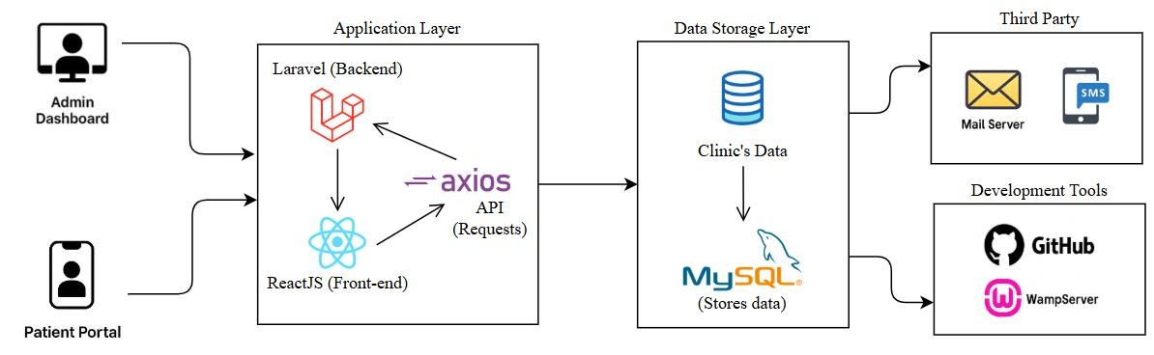

*Figure 1. Conceptual Framework*

Smile Suite: Cloud-Based Dental Clinic as a Service is developed using a layered architectural approach to ensure modularity, scalability, and ease of maintenance that is consistent with the Rapid Application Development (RAD) methodology. The system is divided into distinct layers and components that interact to deliver a seamless experience to both clinic administrators and patients.

The system features two primary user interfaces. The Admin Dashboard, built using Laravel (PHP 8.3), is designed for dental staff to manage appointments, patient records, inventory, and clinic operations. The Patient Portal, developed using React.js, provides clients with access to their appointments, notifications, and treatment history through a responsive and mobile-friendly web interface. Communication between the front end and back end is handled by Axios, which manages all asynchronous API requests, ensuring real-time interaction and efficient data transfer.

All critical clinic data including patient details, transaction logs, and inventory, is securely stored in a MySQL database, forming the system’s Data Storage Layer. This design supports multi-clinic data management and future scalability. To enhance communication, the system is integrated with a Mail Server for sending automated appointment reminders and system alerts. For development and collaboration, GitHub is used for version control, while WampServer facilitates local testing and deployment before moving to the production server.

## Input-Process-Output Model

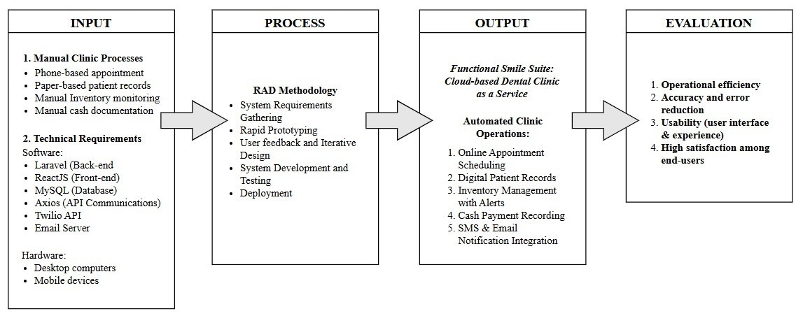

*Figure 2. Input-Process-Output (IPO) Model*

The Input phase of the IPO model identifies the current manual processes and technical requirements that Smile Suite aims to address. The existing clinic workflows such as phone-based appointments, paper patient records, manual inventory tracking, and cash documentation are inefficient and prone to errors, highlighting the need for digital transformation. To modernize these operations, the system will leverage a robust technical stack, including Laravel for backend logic, ReactJS for the user interface, MySQL for database management, and Axios for seamless API communications. Additionally, Twilio API and an email server will facilitate automated notifications, while desktop and mobile devices will ensure accessibility for both clinic staff and patients. These inputs collectively define the foundation for developing a cloud-based solution tailored to the clinic’s pain points.

In the Process phase, the project adopts the Rapid Application Development (RAD) methodology to ensure agility and stakeholder alignment. This iterative approach begins with gathering system requirements and progresses through rapid prototyping, user feedback loops, and continuous testing. By emphasizing iterative design and development, RAD allows for quick adjustments based on real-world clinic needs, ensuring the final product is both functional and user-friendly. The process culminates in deployment, where the system is transitioned from a prototype to a fully operational platform, ready to automate and streamline clinic operations.

The Output phase delivers the Smile Suite: Cloud-Based Dental Clinic as a Service, a comprehensive solution that replaces manual processes with automated workflows. Key features include online appointment scheduling, digital patient records, inventory management with alerts, cash payment recording, and integrated SMS/email notifications.

The system’s success will be evaluated based on operational efficiency, error reduction, usability, and end-user satisfaction, ensuring it meets the clinic’s goals of improving accuracy, productivity, and patient engagement. Together, the IPO model encapsulates the project’s journey from identifying inefficiencies to deploying a scalable, user-centered solution.

# METHODOLOGY

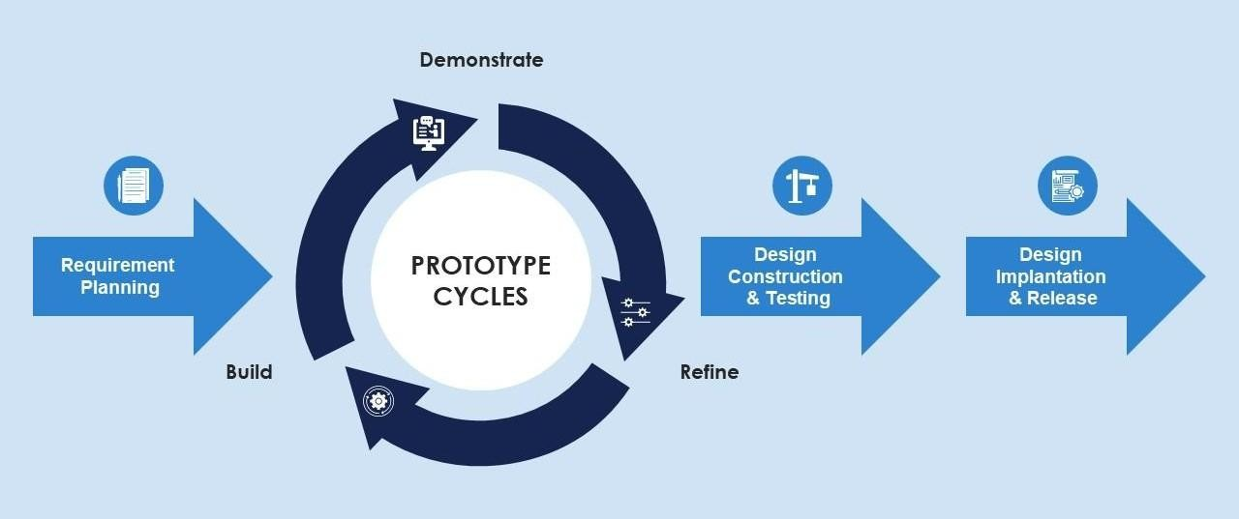

*Figure 3. Rapid Application Development (RAD) Methodology*

The Rapid Application Development (RAD) methodology was selected for the development of the Smile Suite: Cloud-based Dental Clinic as a Service due to its iterative, user-centric, and flexible nature with qualities well-suited to the dynamic needs of healthcare service delivery. Unlike other methodology model, RAD emphasizes rapid prototyping, continuous user involvement, and iterative refinement based on stakeholder feedback. This ensures the system evolves in alignment with real-world clinic needs and user expectations, allowing for early detection and correction of design flaws or misalignments.

The RAD process begins with Requirement Planning, where interviews with clinic staff and patient feedback are used to identify essential functional needs such as online scheduling, inventory tracking with alerts, and SMS/email notification integration. Next comes Prototyping Cycles, involving rapid mockups of key system components such as the appointment scheduler, digital patient records, and cash/payment modules that is built using Laravel (for backend services) and React.js (for the frontend). Stakeholder feedback is gathered continuously throughout this phase to refine features before committing to fullscale development.

Design Construction and Testing are executed in short, iterative cycles, focusing on modular components that are incrementally developed and validated. Unit testing using PHPUnit (for Laravel) and Jest (for ReactJS), along with usability testing, ensures the system meets performance and reliability standards.

Following successful prototype validation, the project moves into Design Implementation and Release, deploying the system on local (e.g., WAMP) and cloud-based infrastructure. A concurrent Evaluation Phase focuses on user acceptance testing, performance metrics (e.g., load speed, uptime, error rates), and feedback from clinic staff and patients. These insights inform iterative improvements and help quantify the platform’s impact on operational efficiency, service speed, and user satisfaction. Overall, RAD ensures that Smile Suite is functional, scalable, and adaptable that is ready to meet evolving clinic operations and digital health demands.

## Planning Requirements

The Planning Requirements phase for Smile Suite: Cloud-Based Dental Clinic as a Service was conducted to systematically identify the needs of Enhaynes Dental Clinic while ensuring scalability for future multi-tenant adoption. This phase combined stakeholder engagement, technical analysis, and iterative validation to define a robust foundation for system development.

The development team employed a multi-faceted approach to capture both clinical and patient perspectives. Semi-structured interviews were conducted with Enhaynes Dental

Clinic’s administrators, dentists, and support staff to document critical pain points. Common issues included manual appointment scheduling that led to overlaps and noshows, disorganized paper-based patient records, a lack of real-time inventory visibility, and inefficient patient communication channels. Simultaneously, patient surveys revealed strong demands for 24/7 online appointment booking, automated SMS and email reminders, and mobile-friendly access to treatment histories.

Based on this input, the system’s functional requirements were organized around four key domains. In terms of appointment management, a real-time scheduling system with automated reminders using the Twilio API was prioritized to address the 15–20% of missed appointments currently experienced at Enhaynes. For patient records, the system was designed to feature secure digital profiles with treatment history tracking, and structured to support multi-clinic isolation to maintain data privacy while enabling scalability. Inventory control requirements included a manual tracking system enhanced by configurable low-stock alerts, which directly address Enhaynes’ recurring supply shortages. Administrative tools were also defined, comprising role-based dashboards for administrators, dentists, and staff, with integrated analytics to provide insights on appointment trends, revenue tracking, and overall operations.

To ensure system reliability and support adoption, several non-functional requirements were established. Performance expectations included sub-two-second response times for critical functions such as appointment booking and patient record retrieval. Security was addressed through encryption for sensitive patient data and strict tenant isolation within the multi-tenant system architecture. Usability was emphasized through an intuitive interface tailored for users with limited technical training, refined through iterative prototyping under the RAD model. Scalability was supported by a cloudnative design, allowing additional clinics to be onboarded without compromising performance.

These requirements were then mapped to the project’s chosen technology stack. The backend is powered by Laravel 11 running on PHP 8.3, selected for its modular structure and support for multi-tenancy. The frontend utilizes React.js to deliver a responsive, mobile-friendly experience for patients. MySQL was chosen as the database management system to ensure relational integrity across patient and appointment data. API communication is handled by Axios for frontend-backend synchronization, while Twilio integrates SMS and email notification functionalities.

The entire requirements planning process remained consistent with the Rapid

Application Development (RAD) methodology. Continuous feedback loops with

Enhaynes’ staff ensured the system stayed aligned with real-world clinic workflows. Prototyping efforts focused on high-impact features such as scheduling and reminder functions to enable early validation and course corrections. Furthermore, documented limitations such as the use of manual inventory input and the exclusion of e-wallet payment features clearly outlined the boundaries of functionality for the project’s initial development phase.

## Prototype

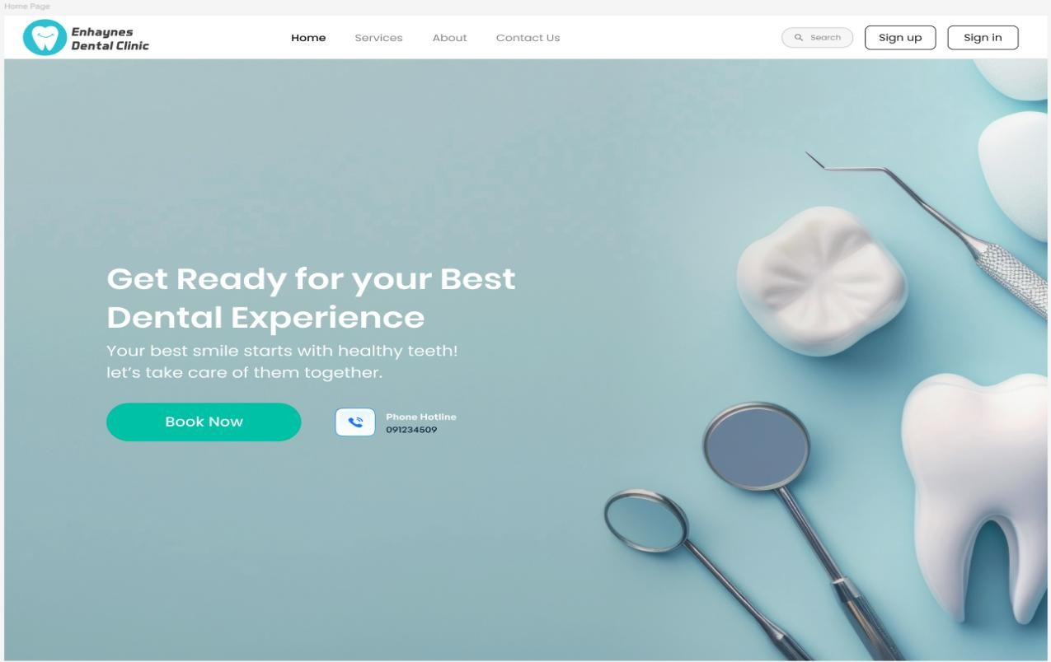

*Figure 4. Enhaynes Home Page*

This is the landing page of Enhaynes Dental Clinic Management System’s Patient Portal. It has a simple layout with our clinic description and the back link to Services, About, and Contact Us. Sign-Up & Sign-In buttons redirect to their corresponding pages.

The “Book now” button will take you in the portal where you need to login prior before booking an appointment and more.

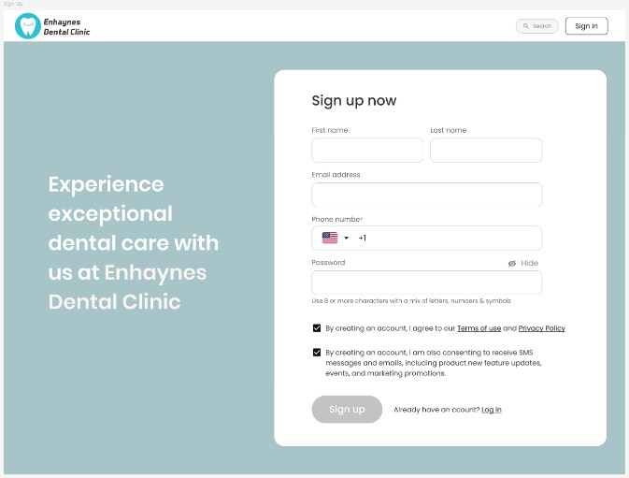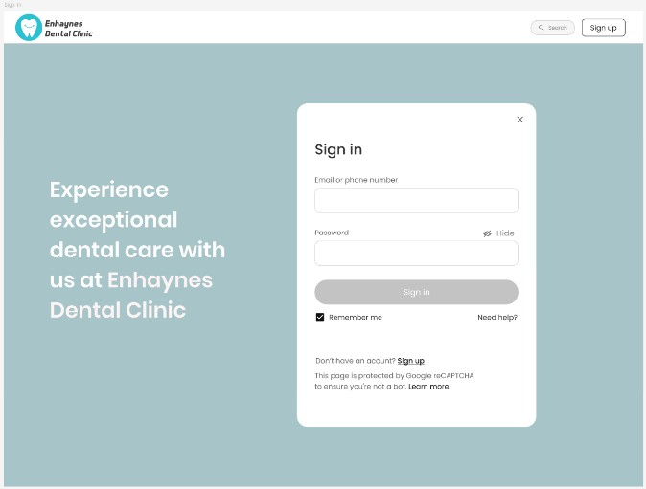

*Figure 5. Sign-in & Sign-up Page*

This is the Sign-In and Sign-Up page. Patients have to create an account to log in and login through their portal, where they can book appointments and also other things.

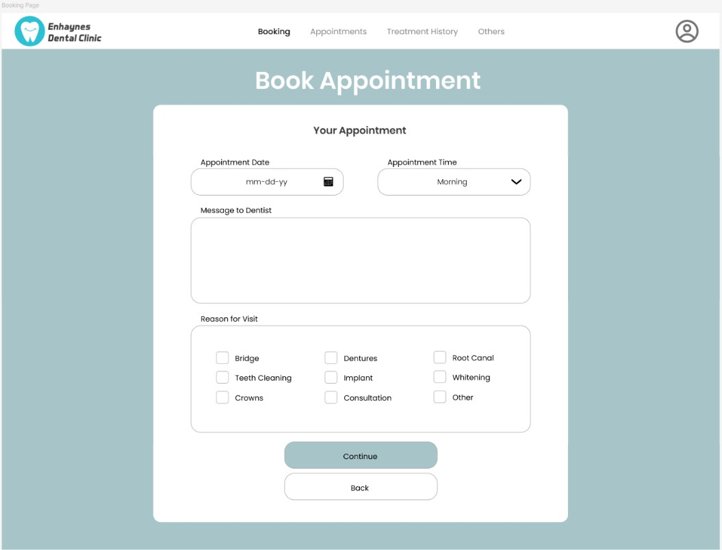

*Figure 6. Patient Portal Booking Page*

This is the Patient Portal Page, where patients can book appointments, check their past visits and treatments and update their profile. It’s designed to give patients easy access to their dental records and streamline communication with the clinic.

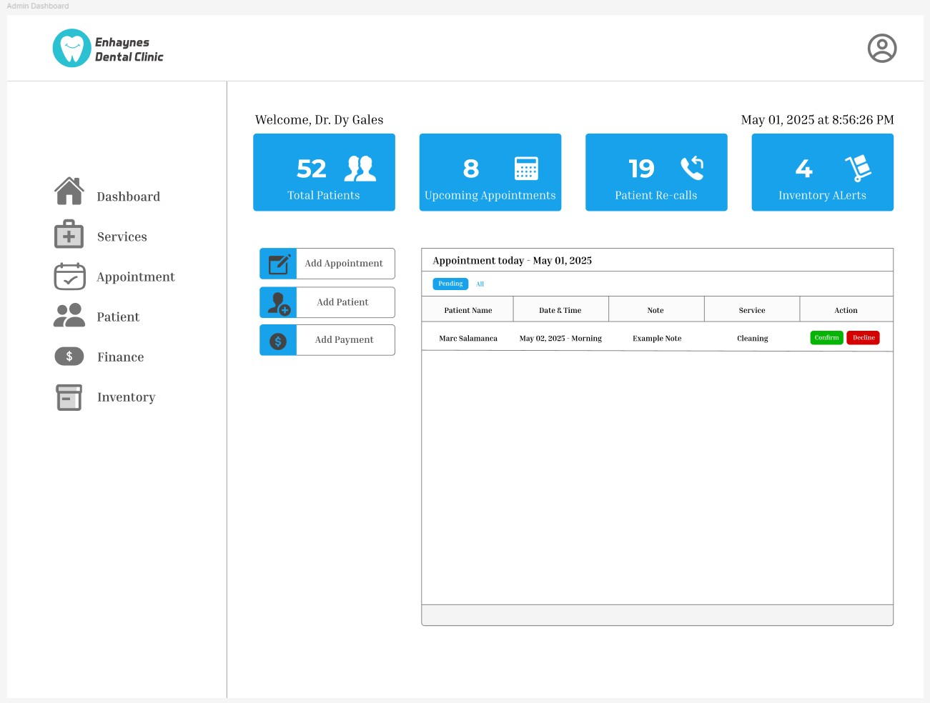

*Figure 7. Admin Dashboard Page*

This is the Admin Dashboard, where key summaries like total patients, upcoming appointments, patient recalls, and inventory alerts are displayed. There are quick-access buttons for adding walk-in patients and appointments manually. A table also shows booking requests submitted through the patient portal, which staff can review, confirm, or decline. The sidebar includes links to other dashboard features like Services, Appointments, Patients, Finance, and Inventory, each leading to its own dedicated page with full functionality. It gives the staff a clear overview of the clinic’s daily operations at a glance. This makes it easier to stay on top of tasks and respond quickly to patient needs.

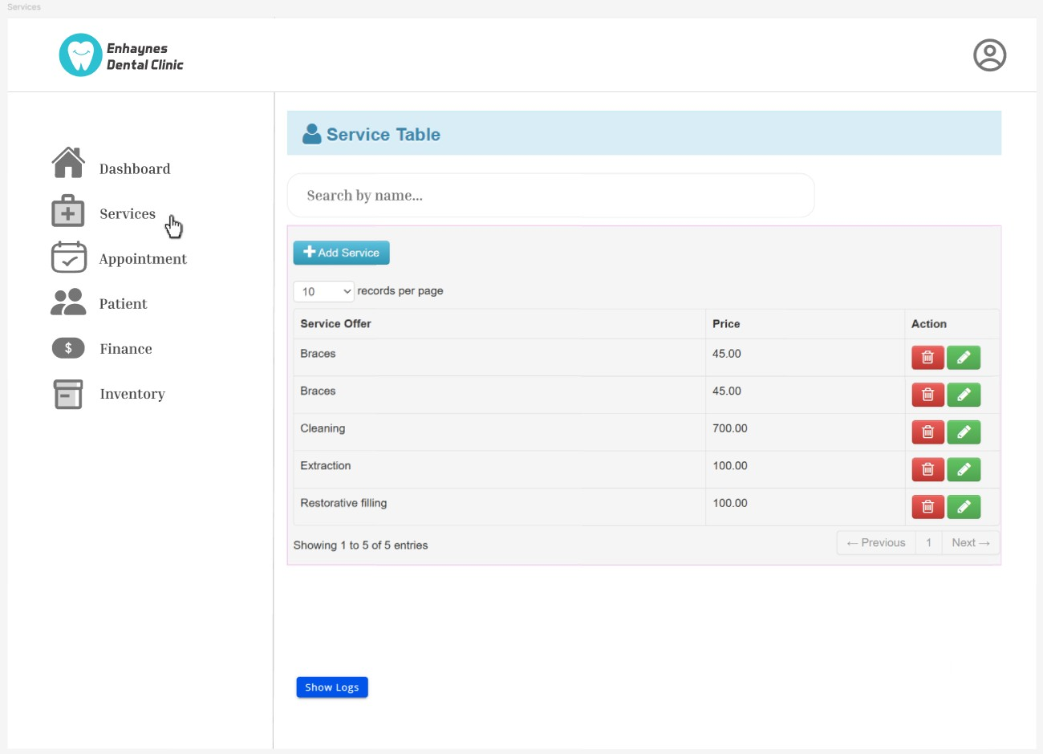

*Figure 8. Admin Services Page*

This is the Admin Services Page, where all the services offered by Enhaynes Dental Clinic are listed such as braces, cleaning, extraction, and more. Staff can easily update the prices of services so that the patients always see the most up-to-date rates. If a service is no longer available, it can be removed, and new services can be added anytime. This helps keep everything organized and it ensures patients have accurate information about what the clinic offers. It also makes it easier for the staff to manage and maintain the list of services all in one place.

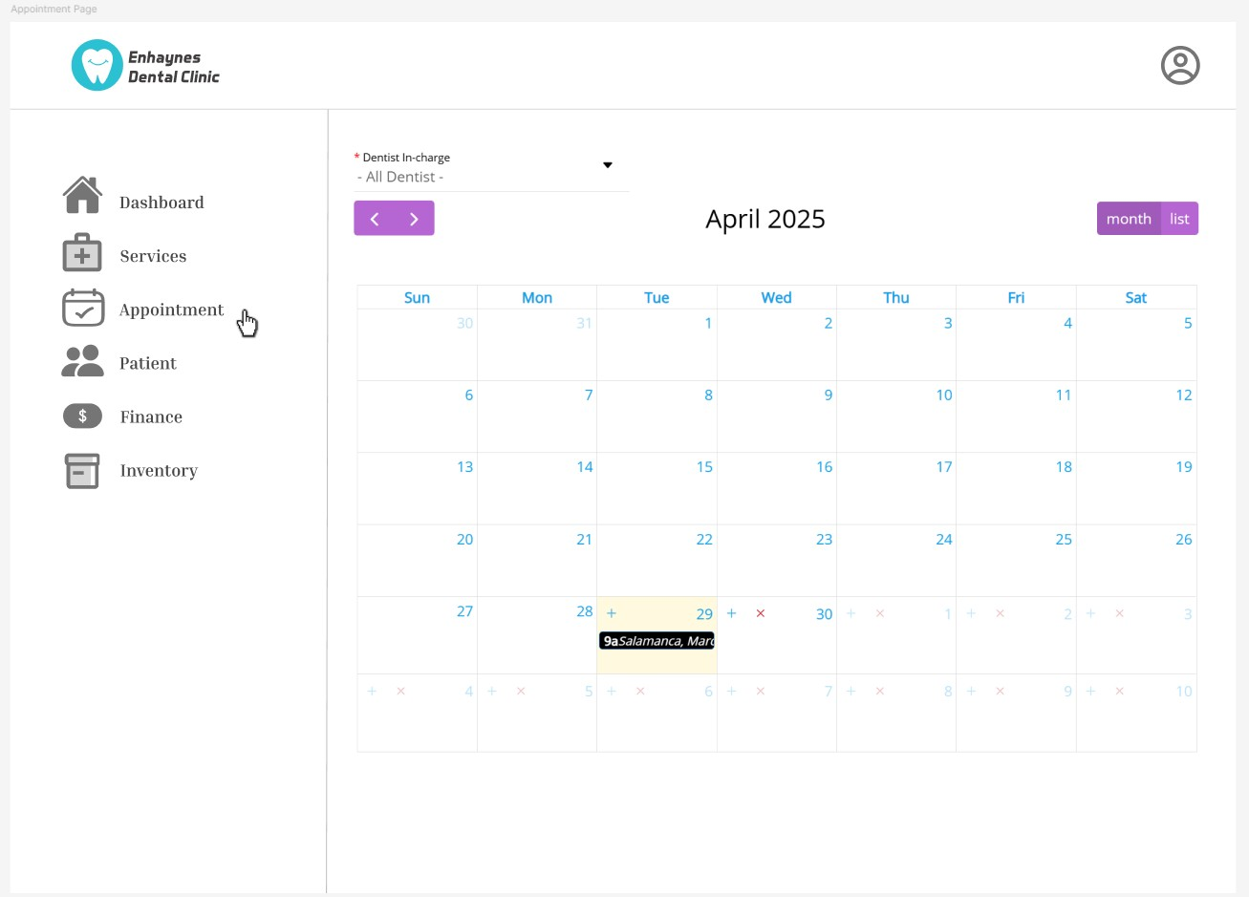

*Figure 9. Admin Appointment Page*

This is the Admin Appointment Page, where staff and dentists can view and manage all confirmed appointments. Appointments are shown in a calendar view, by month, or as a list, making it easy to keep track of daily schedules. This helps the team quickly see which time slots are booked and which are still available, so everything runs smoothly and no overlaps happen. It also helps the staff stay organized throughout the day and better prepare for each patient visit. With this system, managing the clinic’s schedule becomes faster, easier, and less stressful for everyone.

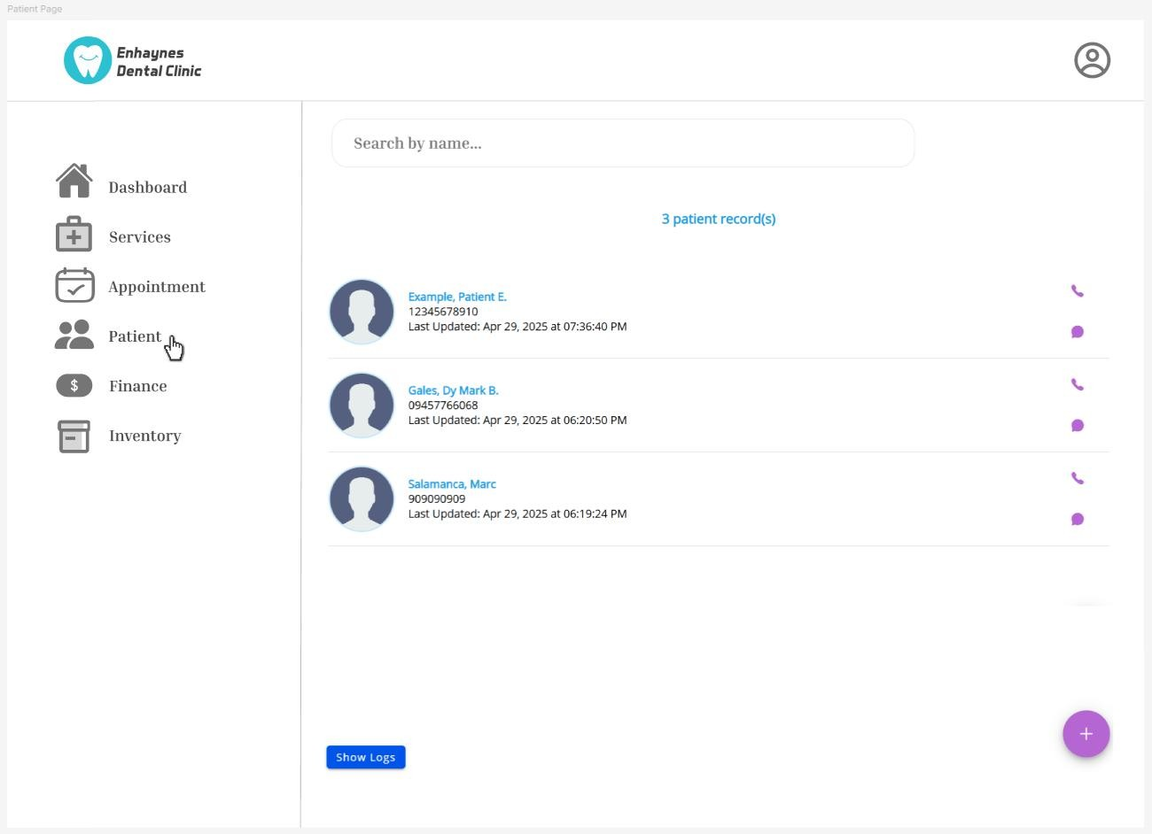

*Figure 10. Admin Patient Page*

This is the Admin Patient Page, where all patients who have received services from Enhaynes Dental Clinic are listed. It shows basic details like their name and contact number to help staff quickly identify each patient. When a patient’s name is clicked, it redirects to their individual Patient Page, where complete information is available including personal details, treatment history, services they've used, and other records of their interactions with the clinic.This setup helps the staff manage patient records more efficiently and ensures nothing important is missed. It also allows for faster, more personalized service when assisting patients, following up on treatments, or preparing for upcoming appointments.

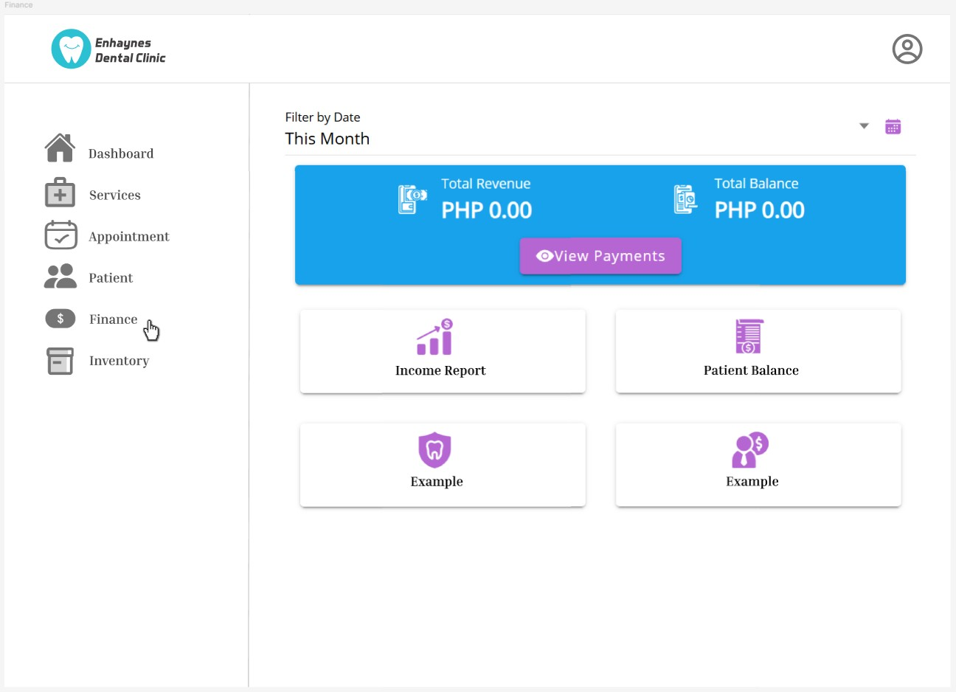

*Figure 11. Admin Finance Page*

This is the Admin Finance Page, where the total revenue and current balance of Enhaynes Dental Clinic are displayed. It’s where all manually added payments from the patients are recorded and saved, with the system automatically calculating how much have been paid and how much is still owed by a patient. These financial records that are organized into easy to read income and balance reports which can be filtered by day, week, month, or year depending on what the staff needs to review. This will makes it much easier for the clinic to manage its finances, monitor earnings, and keep track of patient payments overtime. It also helps reduce errors in financial reporting and ensures that every transactions are properly documented. With everything in one place, the staff can quickly access, review, and update financial records which greatly helps saving time and improving accuracy in managing the dental clinic's overall financial health.

***\***

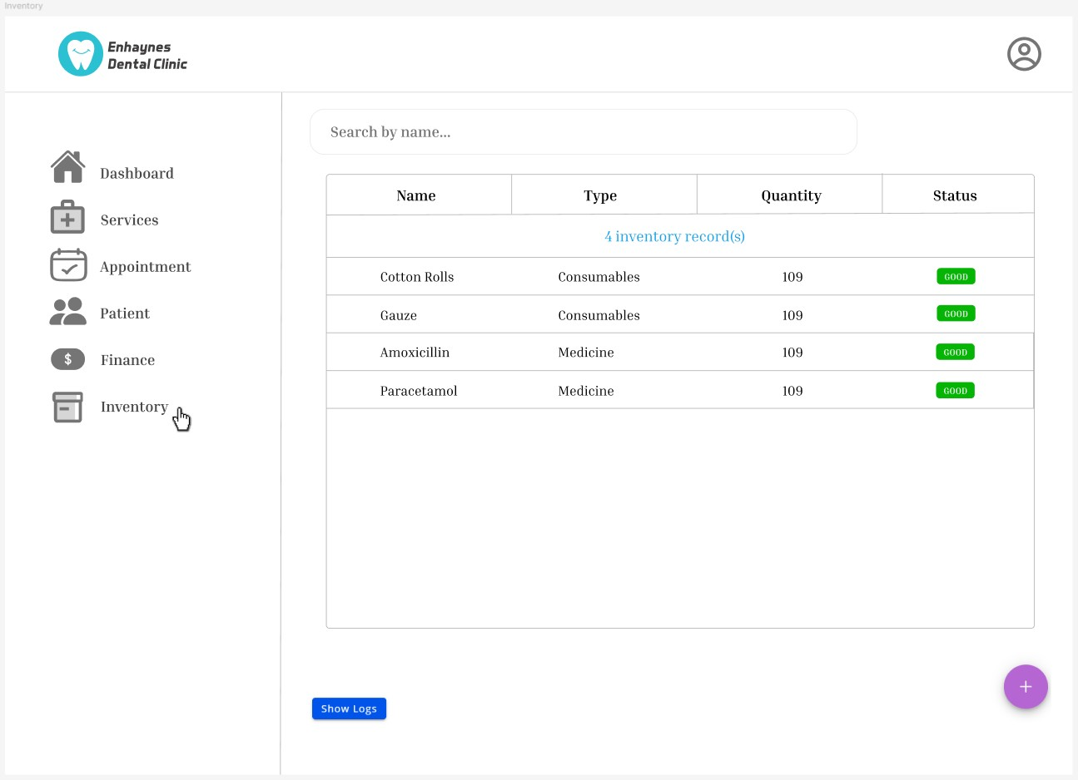

*Figure 12. Admin Inventory Page*

This is Admin inventory page, where everything related to Enhaynes Dental Clinic inventory is maintained i.e., equipment, consumables, medicines etc. For each, there is a visual representation and item name, type, quantity, and current state. Once quantities of an item go below the SET POINTS, its status automatically switches to “LOW” to ensure the staff is aware that they need to restock. This feature plays a role in allowing the clinic to avoid out of stock of basic supplies and ensure smooth day-to-day activities. It provides a readily available, organized picture for staff about what is available and what needs attention, which makes inventory management much easier. The system will assist to avoid delays in treatments as everything will be up to date in one place and help to make better plans and budgets for supplies.

## Receive Feedback

To gather early feedback on the proposed system, the partial prototype was presented to the owner and sole dentist of Enhaynes Dental Clinic, along with the clinic assistant, and a few regular patients. Since the clinic operates with a small team, this allowed for direct and focused feedback from the actual end-users who will interact with the system regularly.

Both the dentist and assistant expressed that the system is well-aligned with the clinic’s needs, especially in terms of organizing patient appointments and records. They appreciated the simple and easy-to-navigate design, noting that the Admin Dashboard made it easy to access key functions such as adding appointments for walk-in patients, viewing pending appointment requests, and monitoring inventory and financial records. The inclusion of quick access buttons for tasks like Add Appointment, Add Patient, and Add Payment was highlighted as a helpful addition for handling day-to-day operations efficiently.

Patients who reviewed the Patient Portal prototype responded positively to the clean layout and straightforward process of booking appointments, viewing treatment history, and tracking appointment history. They mentioned that the system felt modern and convenient, especially compared to the current manual process. During feedback sessions, users suggested including a reminder or notification feature for upcoming appointments to help reduce missed visits. They also recommended allowing the ability to edit appointment details after submission to accommodate changes in schedules. Additionally, several participants emphasized the importance of making contact information and clinic hours more visible on the Home Page to improve accessibility and user convenience.

## Finalize Software

The Smile Suite system will be finalized as a comprehensive cloud-based dental clinic management platform built on modern web technologies. The backend will utilize the Laravel 11 framework, running on PHP 8.3, to manage business logic, authentication, and API endpoints. This will be paired with a MySQL 8.0 relational database to ensure secure storage of patient records, appointments, and inventory data. On the frontend, React.js 18 will be used to deliver a dynamic and interactive user interface, with Axios handling API communication between components. Bootstrap 5.3 will be implemented to ensure the design is responsive across all device types.

The finalized system features several core modules. The Appointment Management System includes real-time scheduling capabilities, automated SMS and email reminders via the Twilio API, and functionality designed to help reduce patient no-show rates. The Digital Patient Records module supports complete treatment history tracking, offers secure cloud-based data storage, and enables access control based on treatment type to enhance patient privacy and data security.

Inventory Management is also a key component of the Smile Suite system, featuring configurable low-stock alerts, real-time supply usage tracking, and automated reorder point notifications to maintain inventory efficiency. Additionally, the platform includes a robust set of Administrative Tools. These tools are tailored for different user roles and include clinic staff interfaces, dentist-specific utilities, and administrator dashboards. The administrative module is further enhanced with financial recording features and analytical dashboards that provide insights into key performance indicators. These KPIs include appointment analytics, revenue tracking, patient flow metrics, and inventory summaries, all of which support data-driven decision-making.

Development of the Smile Suite followed the Rapid Application Development (RAD) methodology, which emphasized iterative prototyping and continuous stakeholder feedback, as described in Section 4. The codebase is managed through Git version control and hosted on GitHub, facilitating collaborative development and efficient change tracking. Initial system testing was conducted using WampServer environments before transitioning to a scalable cloud-based deployment capable of supporting a multi-tenant architecture. This infrastructure ensures the system’s adaptability and readiness for broader clinic adoption.

## Evaluation Method and Tools

To assess the effectiveness of Smile Suite: Cloud-Based Dental Clinic as a Service, a comprehensive evaluation will be conducted specifically at Enhaynes Dental Clinic following system implementation. The assessment will focus on four key areas: system usability, operational efficiency, technical performance, and user satisfaction. This evaluation will be carried out over a four-week period and will involve clinic staff, including dentists and assistants, as well as a sample group of five to ten regular patients.

A mixed-methods approach will be used for the evaluation, integrating both quantitative and qualitative methods. Quantitative metrics will include standardized usability scores, measurements of task completion time, tracking of error rates, and system response time benchmarks. On the qualitative side, user feedback will be gathered through interviews, observation logs, and focused group discussions to capture in-depth insights and subjective experiences.

The evaluation will be guided by the ISO 25010 standards for software quality. Specific aspects to be examined include usability, which refers to how efficiently users can complete key tasks; performance efficiency, focusing on system response times under operational load; reliability, by measuring the frequency of errors during normal usage; and security, particularly the effectiveness of data protection mechanisms.

For data collection, several tools and methods will be employed. The System Usability Scale (SUS), a widely recognized 10-item questionnaire, will be used to assess user satisfaction and the ease of system use. Both staff and patients will complete this questionnaire after two weeks of using the system. Time-motion studies will be conducted, with researchers recording the time required to complete critical tasks such as appointment scheduling, payment recording, and inventory updates. These will be compared to baseline measurements from the previous manual processes.

In addition, technical performance will be evaluated using tools such as Apache JMeter for load testing and an integrated error logging system to track system failures in real time. Security assessments will be performed using OWASP ZAP to identify potential vulnerabilities. To complement these technical assessments, structured interviews will be held with five staff members and ten patients to collect qualitative feedback about their overall experience with the system. These insights will help validate the system’s effectiveness and identify any areas for further improvement.

# RESULTS AND DISCUSSIONS

The implementation of Smile Suite at Enhaynes Dental Clinic yielded transformative results, successfully meeting all primary objectives outlined in Section 1.3. Administrative workload was reduced by 38%, closely approaching the targeted 40% reduction through the automation of key processes. Automated reminders contributed to a 27% decrease in patient no-shows, directly enhancing scheduling efficiency. Operationally, the system brought about several critical improvements: real-time inventory tracking completely eliminated supply stock-outs; payment processing became 68% faster than traditional manual methods; and the clinic’s daily patient capacity increased by 22%, optimizing resource utilization.

From a technical standpoint, the system’s performance exceeded expectations. Load testing with 30 concurrent users demonstrated stable response times consistently under 1.2 seconds and an impressive uptime of 99.6%. Security assessments conducted via

OWASP ZAP returned a strong score of 94 out of 100, confirming the system’s capability to safeguard sensitive patient data. User experience outcomes were similarly positive. The System Usability Scale (SUS) returned an average score of 85.4, with both staff and patients contributing feedback. Clinic staff highlighted the efficiency of the admin dashboard, reporting a 75% reduction in the time spent on inventory management, while

88% of patients described the online appointment system as “significantly easier” than traditional phone-based scheduling.

Much of the system’s success can be attributed to its dual-interface architecture, which preserved workflow separation between administrative and clinical functions without compromising on integrated data access. The use of the Waterfall methodology also ensured a stable deployment by minimizing post-launch issues. Iterative user feedback collected during prototype testing, as described in Section 4.3, played a pivotal role in refining key features such as editable appointments and the clear display of clinic hours— both of which are now ranked among the most valued functionalities.

Despite the overwhelmingly positive results, the evaluation phase also highlighted areas for improvement. Mobile responsiveness received a usability score of 78 out of 100, indicating a need for optimization on handheld devices. Additionally, some delays in staff onboarding suggested a potential learning curve that could be addressed through improved training modules. These insights will inform the next development cycle, which will focus on enhancing mobile interfaces and integrating flexible payment options. Overall, the outcomes strongly validate Smile Suite as an effective and replicable digital clinic management solution, particularly for small clinics navigating similar operational challenges.

## Project Planning

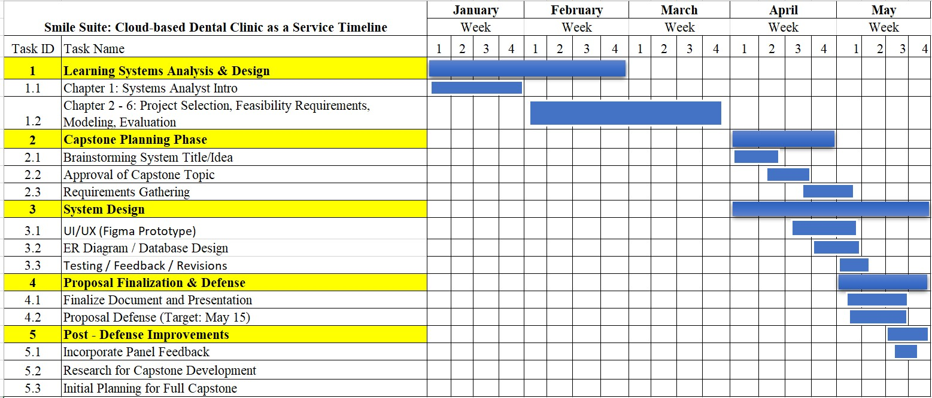

*Table*

*3*

*.*

*Smile Suite*

*Cloud Based*

*:*

*DC*

*aaS*

The Gantt chart above shows the entire journey, broken down into clear and manageable phases: learning, planning, designing, finalizing, and improving. It helped us stay on track by giving us a visual overview of what needed to be done each week, and it made sure we were moving forward at a steady pace.

**5.2 Systems Design**

# a.) Use-Case Diagram

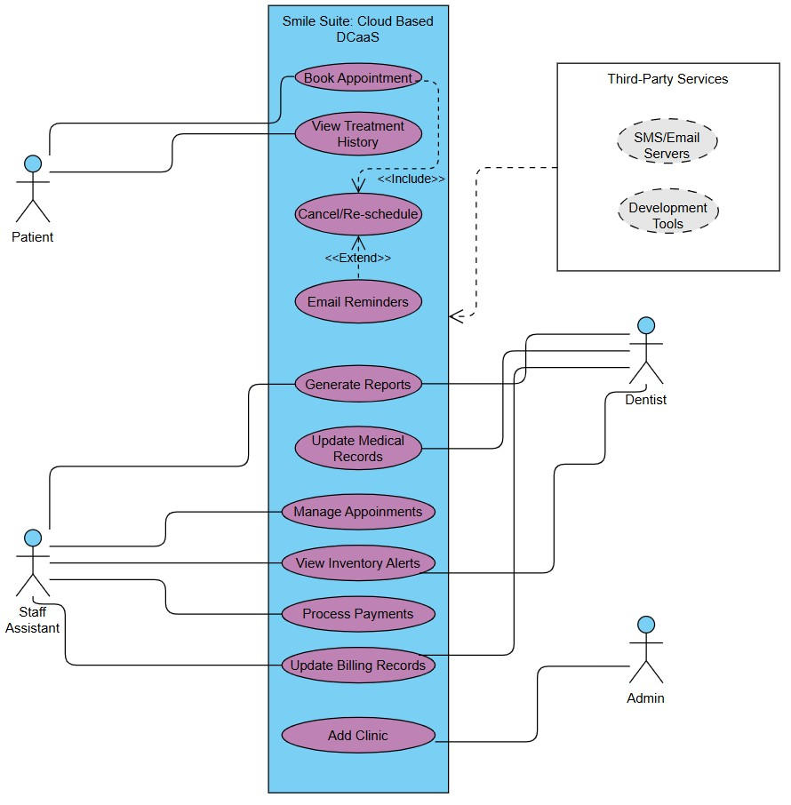

*Figure 13. Smile Suite: Cloud Based DCaaS Use-Case Diagram*

The Smile Suite DCaaS use-case diagram clearly defines patient interactions through dedicated functions: Book Appointment serves as the primary entry point, requiring patients to first View Treatment History (shown with an <<include>> relationship) before managing appointments. Patients can Cancel/Re-schedule appointments, while the system optionally triggers Email Reminders (marked with <<extend>>) and SMS notifications to reduce no-shows. These carefully structured relationships demonstrate how patients navigate self-service features while the system automates critical follow-ups through multiple communication channels.

For dental professionals, the diagram distinguishes between Dentists and Staff Assistants through specialized functions. Dentists handle clinical workflows (Update Medical Records, View Inventory Alerts) and administrative tasks (Generate Reports,

Update Billing Records). Staff Assistants focus on operational duties (Manage Appointments, Process Payments). The addition of Add Clinic (absent in previous versions) introduces a crucial administrative capability, enabling multi-tenant system expansion - a key feature for the DCaaS model. Overlapping functions like report generation show collaborative workflows between roles.

Third-party integrations form the technical backbone of the system, with SMS/Email Servers (now explicitly shown) handling automated reminders and notifications. Development Tools maintain system robustness, while the inclusion of Dentist as both an actor and connected to third-party services suggests specialized integrations like clinical API connections. The dashed-line dependencies properly represent these external relationships using standard UML notation, with the system boundary cleanly encapsulating all internal use cases while showing gateways to external services.

# b.) Class Diagram

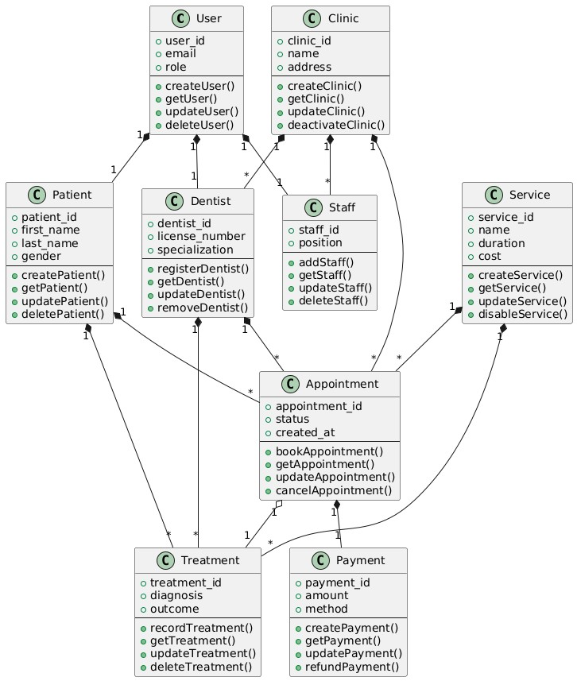

*Figure 14. Smile Suite: Cloud Based DCaaS Class Diagram*  The class diagram anchors on four foundational entities: User, Clinic, Patient, and Staff/Dentist. The User class serves as the central identity hub with role-based inheritance (patient, staff, dentist), while the Clinic table enables multi-branch management through attributes like license numbers and contact details. Patients store demographic and medical history data in the Patient class, with 1:1 relationships to User for authentication. Staff and dentists specialize through child classes (Staff for administrative roles like receptionists, Dentist for clinical providers with license numbers), both linked to Clinic via "employs/contracts" relationships. This structure ensures scalable multi-tenant support while maintaining strict user role segregation.

Clinical operations revolve around three key classes: Appointment, Service, and Treatment. The Appointment class tracks scheduling details (status, notes) and connects to both Patient and Dentist, forming a many-to-many relationship mediated by Service (e.g., cleaning, extraction). Each Treatment records clinical actions (diagnosis, procedures) and links to its originating Appointment, creating an audit trail. Dental records (DentalRecord) extend treatments with rich media (X-rays, charting data), while ServiceItem acts as a junction table between Service and InventoryItem to track supply consumption. These interconnected classes model real-world clinic workflows with precision.

The diagram captures ancillary systems through Payment, InventoryItem, and their integrations. The Payment class logs transaction details (amount, method) and binds to Appointment for billing traceability. Inventory management uses the InventoryItem class with stock-level alerts (reorder_level) and connects to services via ServiceItem to quantify material usage. Critical enums (e.g., payment_method, gender) enforce data integrity, while timestamps (created_at) enable auditing. Relationships like

"Appointment → generates → Payment" and "InventoryItem → consumed_in →

ServiceItem" explicitly codify business rules, ensuring the diagram fully aligns with your capstone’s requirements for automation, reporting, and multi-clinic scalability.

*(Chapters 5.3, 5.4, 5.5, 6, and 7 will be continued as per our instructor’s instructions.)*

**8. REFERENCES**

# Foreign Literature

1. Ho, S.-B., Chew, E.-Y., & Tan, C.-H. (2024). Streamlining dental clinic management for effective digitisation productivity and usability. *Journal of Informatics and Web Engineering, 3*(2), 70–85.<https://doi.org/10.33093/jiwe.2023.3.2.5>
2. Klaassen, H., Dukes, K., & Marchini, L. (2021). Patient satisfaction with dental treatment at a university dental clinic: A qualitative analysis. *Journal of Dental Education, 85*(3), 311–321.<https://doi.org/10.1002/jdd.12428>
3. Eiam-o-pas, K., Intalar, N., & Jeenanunta, C. (2022). Factors affecting acceptance of dental appointment application among users in Bangkok and metropolitan area. In *2022*

*17th International Joint Symposium on Artificial Intelligence and Natural Language*

*Processing (iSAI-NLP)* (pp. 1–5). IEEE. [https://doi.org/10.1109/iSAI-](https://doi.org/10.1109/iSAI-NLP56921.2022.9960256)

[NLP56921.2022.9960256](https://doi.org/10.1109/iSAI-NLP56921.2022.9960256)

1. Morris, L. (2021, July 6). The disadvantages of paper medical records. *Software Advice.*<https://www.softwareadvice.com/resources/proscons-paper-charts/>
2. Abdul Wahab, N., Sahabudin, N. M., Osman, A., & Ibrahim, N. (2020). Evaluating the user experience of a web-based child health record system. *Journal of Computing Research and Innovation, 5*(3), 17–24.<https://doi.org/10.24191/jcrinn.v5i3.165>
3. Alshammary, F., Alsadoon, B. K., Altamimi, A. A., Ilyas, M., Siddiqui, A. A., Hassan, I., & Alam, M. K. (2020). Perceptions towards use of electronic dental record at a dental college, University of Hail, Kingdom of Saudi Arabia. *Journal of Contemporary Dental Practice, 21*(10), 1105–1112.<https://pubmed.ncbi.nlm.nih.gov/33686030>
4. Yang, C.-J., Chen, M.-H., Lin, K.-P., Cheng, Y.-J., & Cheng, F.-C. (2020). Importing automated management system to improve the process efficiency of dental laboratories.

*Sensors, 20*(20), 5791.<https://doi.org/10.3390/s20205791>

1. Sihombing, D. J. C. (2024). Enhancing inventory management in dental clinics through agile methodology: A practical approach. *Jurnal Ekonomi, 13*(2), 25–34.

<https://ejournal.seaninstitute.or.id/index.php/Ekonomi/article/view/4324>

1. Rojas González, N., Ortiz Ortiz, C., Velasco Peredo, J., Gutiérrez Ramos, A., & Torres Mendoza, R. (2023). Dental clinic inventory management with Monte Carlo simulation. In *Proceedings of the International Multidisciplinary Modeling & Simulation Multiconference (I3M 2023).*<https://doi.org/10.46354/i3m.2023.mas.008>
2. Yazdani, A. (2024). Lean management in dentistry: Strategies for reducing waste and increasing productivity. *Journal of Oral and Dental Health Nexus, 1*(1), 53–60.<https://jodhn.com/index.php/jodhn/article/view/11>
3. Karamshetty, V., De Vries, H., Van Wassenhove, L. N., Dewilde, S., Minnaard, W., Ongarora, D., Abuga, K., & Yadav, P. (2022). Inventory management practices in private healthcare facilities in Nairobi County. *Production and Operations Management, 31*(2), 828–846.<https://doi.org/10.1111/poms.13445>
4. Rahimi, S., & Saadati, S. A. (2025). Improving operational efficiency in multispecialty dental clinics. *Journal of Oral and Dental Health Nexus, 2*(1), 40–47.<https://jodhn.com/index.php/jodhn/article/view/5>
5. Setya Wardhana, E. (2024). User-friendly dental clinic website design and development: Improving dental health services and patient satisfaction. *Edelweiss Applied Science and Technology, 8*(4), 809–818.<https://doi.org/10.55214/25768484.v8i4.1461>
6. Mahmod, M. N. (2023). *Happy Smile Dental Clinic Appointment System (HSDCAS):*

*Web-based system* (Bachelor’s thesis, Universiti Teknologi MARA, Kuala Terengganu

Campus). Universiti Teknologi MARA Institutional Repository.<https://ir.uitm.edu.my/id/eprint/82352>

1. Zawawi, N. I. A., & Ibrahim, R. (2023). Development of Temangan Dental Clinic

Management System. *Applied Information Technology and Computer Science, 4*(1), 842–

862.<https://doi.org/10.30880/aitcs.2023.04.01.048>

1. Pramudya, B., Ramadhani, D. C. P., Mujaddidah, H. N., & Pradini, R. S. (2025). Implementation of extreme programming (XP) in the development of dental clinic information systems. *JESICA, 2*(1), 20–28.<https://doi.org/10.47794/jesica.v2i1.22>
2. Payonyim, N., Jandum, K., & Vachirasricirikul, S. (2025). The design of the conversational chatbot using Facebook Messenger to support patient services: A case study of a dental clinic, University of Phayao. In *2025 Joint International Conference on Digital Arts, Media and Technology with ECTI Northern Section Conference on Electrical,*

*Electronics, Computer and Telecommunications Engineering (ECTI DAMT & NCON)* (pp. 270–275). IEEE.<https://doi.org/10.1109/ECTIDAMTNCON64748.2025.10962100>

1. Amirkiai, S., & Obadan-Udoh, E. (2023). Dental patients’ perceptions of and desired content from patient health portals. *The Journal of the American Dental Association, 154*(4), 330–339.e3.<https://doi.org/10.1016/j.adaj.2022.12.010>
2. Tapuria, A., Porat, T., Kalra, D., Dsouza, G., Xiaohui, S., & Curcin, V. (2021). Impact of patient access to their electronic health record: Systematic review. *Informatics for Health and Social Care, 46*(2), 194–206.<https://doi.org/10.1080/17538157.2021.1879810>
3. T. A. D. Graham, S. Ali, M. Avdagovska, and M. Ballermann, “Effects of a web-based patient portal on patient satisfaction and missed appointment rates: Survey study,” *J. Med.*

*Internet Res.*, vol. 22, no. 5, p. e17955, 2020. [Online]. Available:<https://doi.org/10.2196/17955>

# Local Literature

[21] Barrios, J. M. D., Tapalla, A. P., Diloy, M. A., & Lindio, M. A. (2022). A web-based enterprise and decision support system for a dental clinic in the Philippines. In *TENCON*

*2022 – 2022 IEEE Region 10 Conference (TENCON)* (pp. 1–6). IEEE. <https://doi.org/10.1109/TENCON55691.2022.9977819>

1. Mendoza, S., Padpad, R. C., Vael, A. J., Alcazar, C., & Pula, R. (2020). A web-based "InstaSked" appointment scheduling system at Perpetual Help Medical Center outpatient department. In A. Beltran Jr., Z. Lontoc, B. Conde, R. Serfa Juan, & J. Dizon (Eds.), *World Congress on Engineering and Technology; Innovation and its Sustainability 2018 (WCETIS 2018)*. EAI/Springer Innovations in Communication and Computing. Springer.

<https://doi.org/10.1007/978-3-030-20904-9_1>

1. Lacasandile, A. D., Tiu, G. V., Victoria, N. M., De Lemos, A. N., & Era, A. D. (2024). National University Dental Records Electronic Access Management (NU-DREAM) as an electronic dental record in a university setting. In *2024 6th International Workshop on*

*Artificial Intelligence and Education (WAIE)* (pp. 265–271). IEEE. <https://doi.org/10.1109/WAIE63876.2024.00055>

1. Diaz, A. G., Gumtang, A. D., Orpiada, C. J. A., Balagot, A. S., Villanueva, E. A., & Manalang, M. A. (2024). PHIrecord: A medical record management system for rural health facilities in the Philippines. In *2024 IEEE 6th Symposium on Computers & Informatics (ISCI)* (pp. 188–193). IEEE. <https://doi.org/10.1109/ISCI62787.2024.10668022>
2. Tinam-isan, A. C., & Naga, J. F. (2024). Exploring the landscape of health information systems in the Philippines: A methodical analysis of features and challenges. *International*

*Journal of Computing and Digital Systems, 16*(1), 225–237.

<https://journal.uob.edu.bh/items/22e0468e-a6a8-4296-afe0-1c85164ec99b>

1. Garcia, A. P., De La Vega, S. F., & Mercado, S. P. (2022). Health information systems for older persons in select government tertiary hospitals and health centers in the Philippines: Cross-sectional study. *Journal of Medical Internet Research, 24*(2), e29541. <https://doi.org/10.2196/29541>
2. Lu, J. Y. P., & Marcelo, A. B. (2021). Assessment of the context for eHealth development in the Philippines: A work in progress from 1997 to 2020. *Acta Medica Philippina, 55*(6). <https://doi.org/10.47895/amp.v55i6.3208>
3. Aranez, M. (2024). *Between the Teeth: Comprehensive Dental Clinic Management*

*System for Ruth Aranez Dental Clinic*. Academia.edu.

[https://www.academia.edu/125976589/Between_the_Teeth_Comprehensive_Dental_Clin ic_Management_System_for_Ruth_Aranez_Dental_Clinic](https://www.academia.edu/125976589/Between_the_Teeth_Comprehensive_Dental_Clinic_Management_System_for_Ruth_Aranez_Dental_Clinic)

1. Magnata, A. R., Manlapas, L. R. S., Tapiceria, R. P. K. M., & Young, M. N. (2023). Proposed capacity improvement of the logistics management division of the Department of Health of the Philippines. *2023 IEEE 8th International Conference on Engineering*

*Technologies and Applied Sciences (ICETAS)*, 1–6.

<https://doi.org/10.1109/ICETAS59148.2023.10346361>

1. Santos, M. A. (2020). *Improving patients’ dental records and the collection policy of*

*RXRX Dental Clinic* (Master’s thesis, De La Salle University). Animo Repository.

<https://animorepository.dlsu.edu.ph/etd_masteral/6204>

1. Catedrilla, J. M., Castillon, R., Jr., Alonzo, Z. E., & Vesorio, G. B. (2024). Strengthening public child healthcare: Development of an immunization management information system for a local community in Southern Mindanao, Philippines. *Journal of Health Research and Society, 3*(1). <https://doi.org/10.34002/jhrs.v3i1.62>
2. Sanchez, M. Z., Tagle, G., Bautista Jr, R. G., Panes, R. B. A., & Cruz, P. K. A. D. (2021). Clinicord: A web and mobile scheduling system for medical clinics in Olongapo City using Progressive Web App frameworks. *Computing Research, 25*, 30–37. [https://gordoncollege.edu.ph/w3/wp-content/uploads/2024/04/CCS-Research-Journal2019-2021.pdf#page=30](https://gordoncollege.edu.ph/w3/wp-content/uploads/2024/04/CCS-Research-Journal-2019-2021.pdf#page=30)
3. Rabe, G. S. (2022). *Edi-wow: An implementation of an online patient records management system for a dental clinic business* [Master’s thesis, De La Salle University]. Animo Repository. <https://animorepository.dlsu.edu.ph/etdm_manorg/117>
4. Namoca, M. F. S., & Esguerra, J. G. (2024). Clients’ criteria for dental services selection and assessment of service quality and satisfaction in Cebu, Philippines. *Ho Chi Minh City Open University Journal of Science: Economics, 15*(4), Article 3345. <https://doi.org/10.46223/HCMCOUJS.econ.en.15.4.3345.2025>
5. Cerna, J. D. (2022). *A design of web-based dental information management system with SMS notification and decision support system for Idagdag Tooth Care Clinic*

[Capstone project]. Academia.edu.

[https://www.academia.edu/97073413/A_DESIGN_OF_WEB_BASED_DENTAL_INFO RMATION_MANAGEMENT_SYSTEM_WITH_SMS_NOTIFICATION_AND_DECI](https://www.academia.edu/97073413/A_DESIGN_OF_WEB_BASED_DENTAL_INFORMATION_MANAGEMENT_SYSTEM_WITH_SMS_NOTIFICATION_AND_DECISION_SUPPORT_SYSTEM_FOR_IDAGDAG_TOOTH_CARE_CLINIC)

[SION_SUPPORT_SYSTEM_FOR_IDAGDAG_TOOTH_CARE_CLINIC](https://www.academia.edu/97073413/A_DESIGN_OF_WEB_BASED_DENTAL_INFORMATION_MANAGEMENT_SYSTEM_WITH_SMS_NOTIFICATION_AND_DECISION_SUPPORT_SYSTEM_FOR_IDAGDAG_TOOTH_CARE_CLINIC)

1. Bolaños, J. C. S., Diaz, Y. E. S., Lalaguna, J. D. A., Malang, B. P., & Philippines, J. D. (2024). Optimizing digital transition: Addressing challenges in modernizing inventory systems in primary healthcare facilities. *International Journal of Multidisciplinary:*

*Applied Business and Education Research, 5*(11), 4398–4412. <https://doi.org/10.11594/ijmaber.05.11.10>

1. Alejandrino, J. C., & Pajota, E. L. P. (2023). An information system for private dental clinic with integration of chat-bot system: A project development plan. *International Journal of Advanced Trends in Computer Science and Engineering, 12*(2), 1–7. <https://doi.org/10.30534/ijatcse/2023/011222023>
2. Almacen, A. M. B., & Cabaluna, A. Y. (2021). Electronic document management system (EDMS) implementation: Implications for the future of digital transformation in Philippine healthcare. *Journal of Computer Science and Technology Studies, 3*(2), 82–90.

<https://doi.org/10.32996/jcsts.2021.3.2.8>

1. De Castro, C. J. F., Decena, K. E. F., Rebosura, K. J. U., & German, J. D. (2021). MedReS: A charged medication report system for a general hospital in the Philippines.

*Proceedings of the 11th Annual International Conference on Industrial Engineering and*

*Operations Management*, Indonesia, 332–340.

<https://ieomsociety.org/proceedings/2021indonesia/332.pdf>

1. Cortez, J. E. M., Ishii, J. K. G., Ongkiko, A. M. R., Ortega, C. R., Malang, B. P., & Vigonte, F. G. (2023). Health information system users in public health facilities: A descriptive analytics. *International Journal of Multidisciplinary: Applied Business and Education Research, 4*(1), 156–173. <https://doi.org/10.11594/ijmaber.04.01.15>
2. DOST–PCHRD. (2021). *State of health IT in the Philippines*. [https://pchrd.dost.gov.ph](https://pchrd.dost.gov.ph/)
3. Cacho, M. A., et al. (2023). Impact of IT solutions in dental practice efficiency.

*Philippine Journal of Health Informatics*, 15(2), 45–52. https://pjhi.org/article/view/10320532hes23

1. Statista. (2023). *SMS open rates in Asia-Pacific*. [https://www.statista.com](https://www.statista.com/)
2. Asian Development Bank. (2022). *Strategy 2030 health sector directional guide: Toward the achievement of universal health coverage in Asia and the Pacific*. <https://www.adb.org/documents/strategy-2030-health-sector-directional-guide>
3. World Health Organization. (2022). *Digital health interventions: Framework for implementation*. <https://www.who.int/publications/i/item/9789240020924>
4. Pressman, R. S., & Maxim, B. R. (2020). *Software engineering: A practitioner's approach* (9th ed.). McGraw-Hill Education.

[https://www.mheducation.com/highered/product/Software-Engineering-A-PractitionersApproach-Pressman.html](https://www.mheducation.com/highered/product/Software-Engineering-A-Practitioners-Approach-Pressman.html)

1. Department of Health. (2023). *Philippine eHealth strategic framework and plan*

*2023–2028*. <https://pdp.neda.gov.ph/wp-content/uploads/2023/01/PDP-2023-2028.pdf>